Report: Analysis of Divide and Conquer Algorithms

Abstract
This report reviews two divide-and-conquer algorithms—Closest Pair of Points and Karatsuba Integer Multiplication—showing how recursive decomposition improves efficiency compared to naïve O(n²) approaches. The closest-pair method reduces complexity to O(n log n), while Karatsuba lowers large-integer multiplication to O(n¹·⁵⁸⁵).

Introduction
Both the algorithms work by breaking a problem into smaller sub-problems, solving them recursively, and merging results in the end.

Proposed System
1. Karatsuba Multiplication Visualization: The system accepts two integers, checks the base case, and otherwise splits them to compute three reduced products. Visual branching shows recursive decomposition.
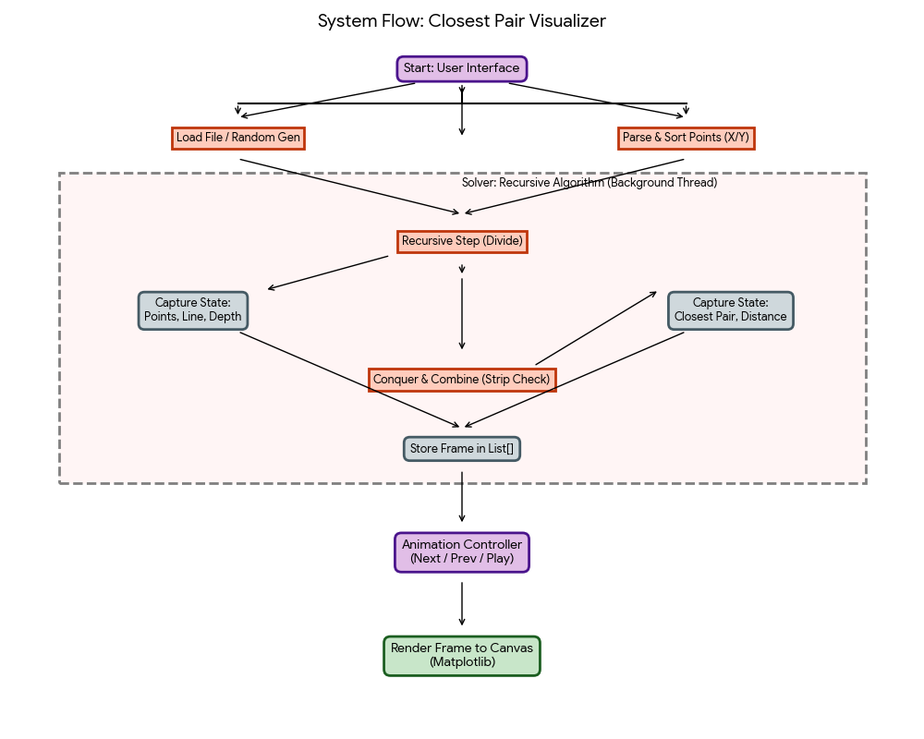

2. Closest Pair Visualization: The system loads a point file and captures states during Solve Phase, then replays them in the Playback Phase with controls for navigation.
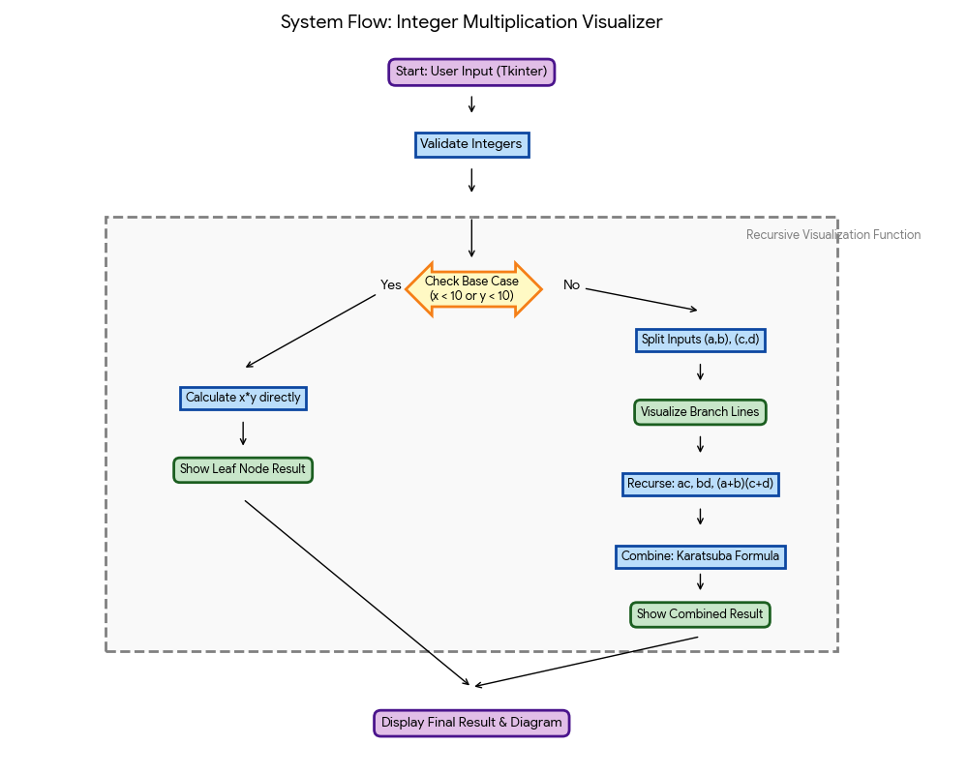
Experimental Setup
Closest Pair Algorithm
  - Dataset: 120 points with random uniform distribution (x ∈ [1, 996], y ∈ [7, 981]).
  - Parameters: Base case for ≤3 points, strip optimization checking 6 subsequent points.
Integer Multiplication Algorithm
  - Input: Random integers (4-5 digits).
  - Base Case: Direct multiplication for numbers < 10.
  - Method: Recursive splitting using the Karatsuba formula.

Results and Discussion
Closest Pair Results
  - Nearest Pair: (844, 115) and (277, 115)
  - Minimum Distance: 567.0 units.
  - Performance: 45 visual frames generated, 8 strip checks performed, 15 brute-force base cases.
  - Visualization: Effectively illustrated recursive division, strip checking, and the refinement of the closest pair candidate.
Integer Multiplication Results
  - Sample: 1234 × 5678 = 7,006,652 (Verified successfully).
  - Performance: Achieved O(n^log₂3) ≈ O(n^1.585) complexity.
  - Visualization: Clearly represented the recursive decomposition and merging process, demonstrating the efficiency gain over the traditional method.

Conclusions
Both algorithms highlight the efficiency of divide and conquer: the closest-pair method runs in (O(n \log n)), and Karatsuba improves integer multiplication performance. Their visualizers clarify each algorithm’s steps, from geometric splitting to recursive multiplication. These methods apply to geometry, graphics, cryptography, and numerical computation, with future improvements possible in large-dataset visualization and higher-dimensional extensions.

References
- Cormen, T. H., Leiserson, C. E., Rivest, R. L., & Stein, C. (2009). Introduction to Algorithms. MIT Press.
- Karatsuba, A., & Ofman, Y. (1962). Multiplication of Many-Digital Numbers by Automatic Computers.
- Preparata, F. P., & Shamos, M. I. (1985). Computational Geometry: An Introduction. Springer.
- Bentley, J. L. (1980). Divide and Conquer Algorithms for Closest Point Problems.

